PROJECT DOCUMENTATION

AI BLOGNEST

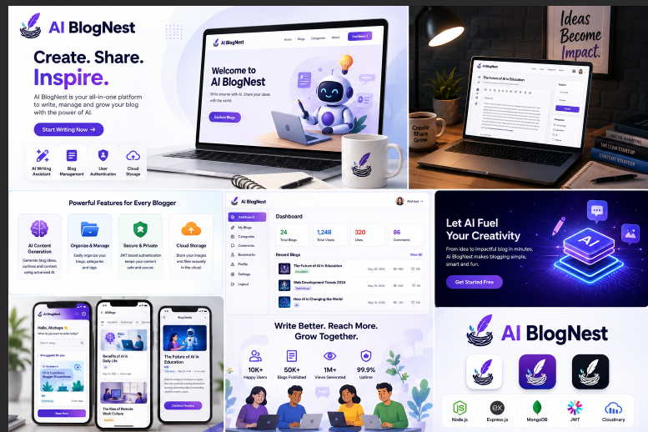

Project Title: AI BlogNest

Team Leader:

Hemavarshini.M- 24cshemavarshini033@gmal.com

Team member:

Harine.M.A- 24csharine030@gmail.com

Haripriya.B- 24csharipriya031@gmail.com

Hemavarshini.v- 24cshemavarshini032@gmail.com

AI BlogNest:

Generate high-quality blog content using AI

Description
AI BlogNest is an AI-powered content management and blogging platform developed to simplify blog creation, content management, and AI-assisted writing. The system is designed as a secure and scalable REST API backend that provides various services required for
managing users, blogs, comments, categories, and AI-generated content.

The application is developed using Node.js and Express.js, which provide the server-side environment and RESTful API architecture. MongoDB is used as the primary database, while Mongoose ODM is used for data modeling, schema validation, and efficient interaction with the database. The system follows a modular architecture that separates routing, controllers, services, authentication, and database operations, making the application easier to maintain
and extend.
A major feature of AI BlogNest is its integration with Google Gemini AI. The AI functionality assists users in creating high-quality blog content based on their given topics or
requirements. The system also provides AI-based content summarization, which helps convert lengthy blog content into concise and meaningful summaries. These AI capabilities reduce the effort involved in content creation and improve the overall blogging workflow.
The platform provides complete blog management functionality, including creating, retrieving, updating, and managing blog posts. It also supports categories and tags for organizing content and improving content discoverability. Comment management
functionality allows users to interact with published blog posts, while moderation features help authorized users manage comments and maintain content quality.
Security is an important part of the system. JWT (JSON Web Token) is implemented for
secure and stateless user authentication, while bcrypt.js is used for securely hashing user
passwords. The system also implements role-based access control, providing different levels of access for Admin, Editor, Author, and Reader roles. Each role is provided with appropriate permissions based on its responsibilities within the platform.
The system follows an MVC-based architectural approach. The Model layer defines the
database structures using Mongoose schemas, the Controller layer handles application logic and processes incoming requests, and the API routing layer connects client requests with the appropriate controllers. This separation of responsibilities improves the organization, maintainability, and scalability of the application.

Scenario-Based Case Study
Background
Arun is a freelance writer who regularly creates technical and general-interest blogs. He spends a lot of time thinking about suitable topics, preparing blog content, creating
summaries, and organizing his published articles. Managing all these activities manually
makes the content creation process slow and difficult.

Problem
- Difficulty in generating fresh blog ideas.
- Difficulty in preparing complete blog articles within a short period of time.
- Difficulty in creating summaries for lengthy blog articles.
- Difficulty in organizing and managing blog content efficiently.
- Difficulty in managing user access when multiple users are involved.
- Need for secure protection of blog and user information.
Solution

AI BlogNest provides an AI-assisted blogging environment that helps Arun simplify the content creation process. By providing a topic or basic requirement, the AI functionality can assist in generating suitable blog content. The summarization feature can also be used to
create concise summaries from existing blog content. The platform provides blog management features that allow content to be stored and managed systematically.
The system also provides secure authentication and role-based access control. Different users can access the system according to their assigned roles, ensuring that users can
perform only the operations permitted to them. MongoDB is used to store the required user and blog information, while the REST API manages communication between the application components.
Usage
- The Author can create and manage blog posts and use AI features for content generation and summarization.
- The Editor can review and manage blog content according to the assigned permissions.
- The Admin can manage users, roles, comments, and other administrative operations.
- The Reader can view published blogs and interact with the available comment features.
Outcome
By using AI BlogNest, Arun can reduce the time required for creating and organizing blog content. AI-assisted generation helps with preparing content, while the summarization feature makes lengthy information easier to understand. The role-based security system
provides controlled access for different users, and the REST API with MongoDB provides a structured approach for managing the application's data and operations.
- Software Requirements
  - Operating System – Windows 10 or Windows 11
  - Backend Runtime – Node.js
  - Package Manager – npm
  - Backend Framework – Express.js
  - Database – MongoDB
  - Database Management – Mongoose ODM
  - AI Service – Google Gemini AI
  - API Testing Tool – Postman
  - Development Environment – Visual Studio Code
  - Web Technologies – REST API, JSON, HTTP/HTTPS
- Hardware Requirements
  - Processor – Intel Core i5 or equivalent
  - RAM – Minimum 8 GB
  - Storage – Minimum 1 GB free space
  - System – Laptop or Desktop Computer

  - Network – Stable Internet Connection

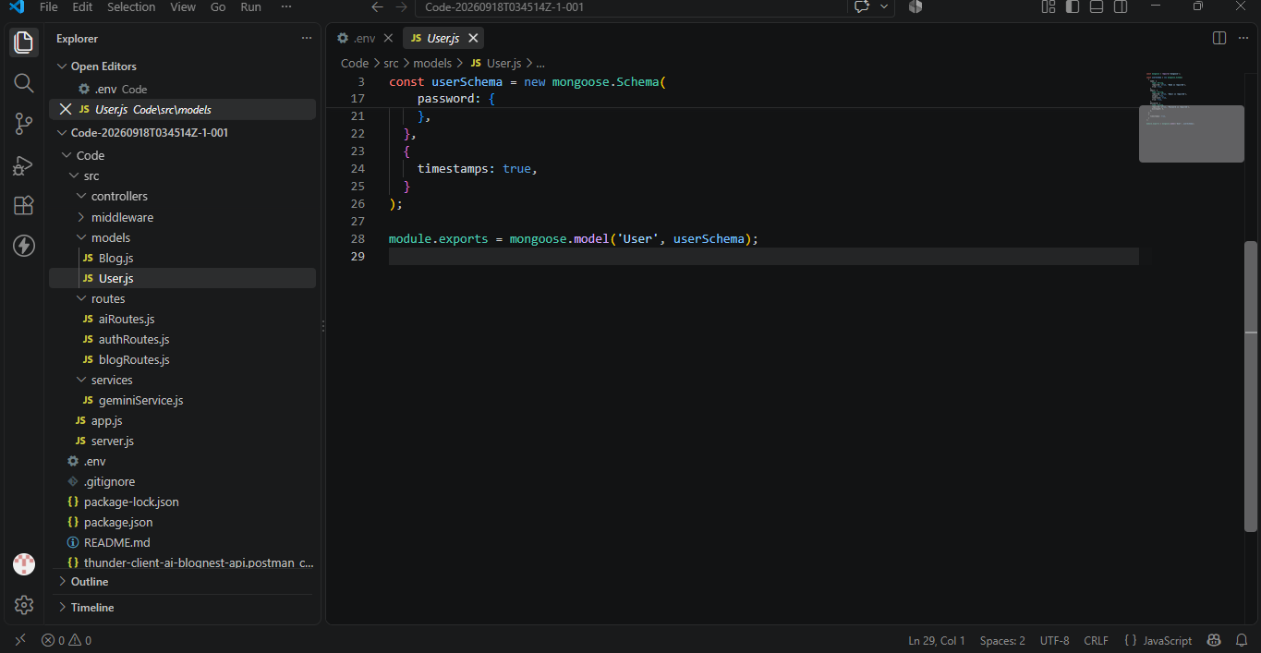

SYSTEM DESIGN AND ARCHITECTURE
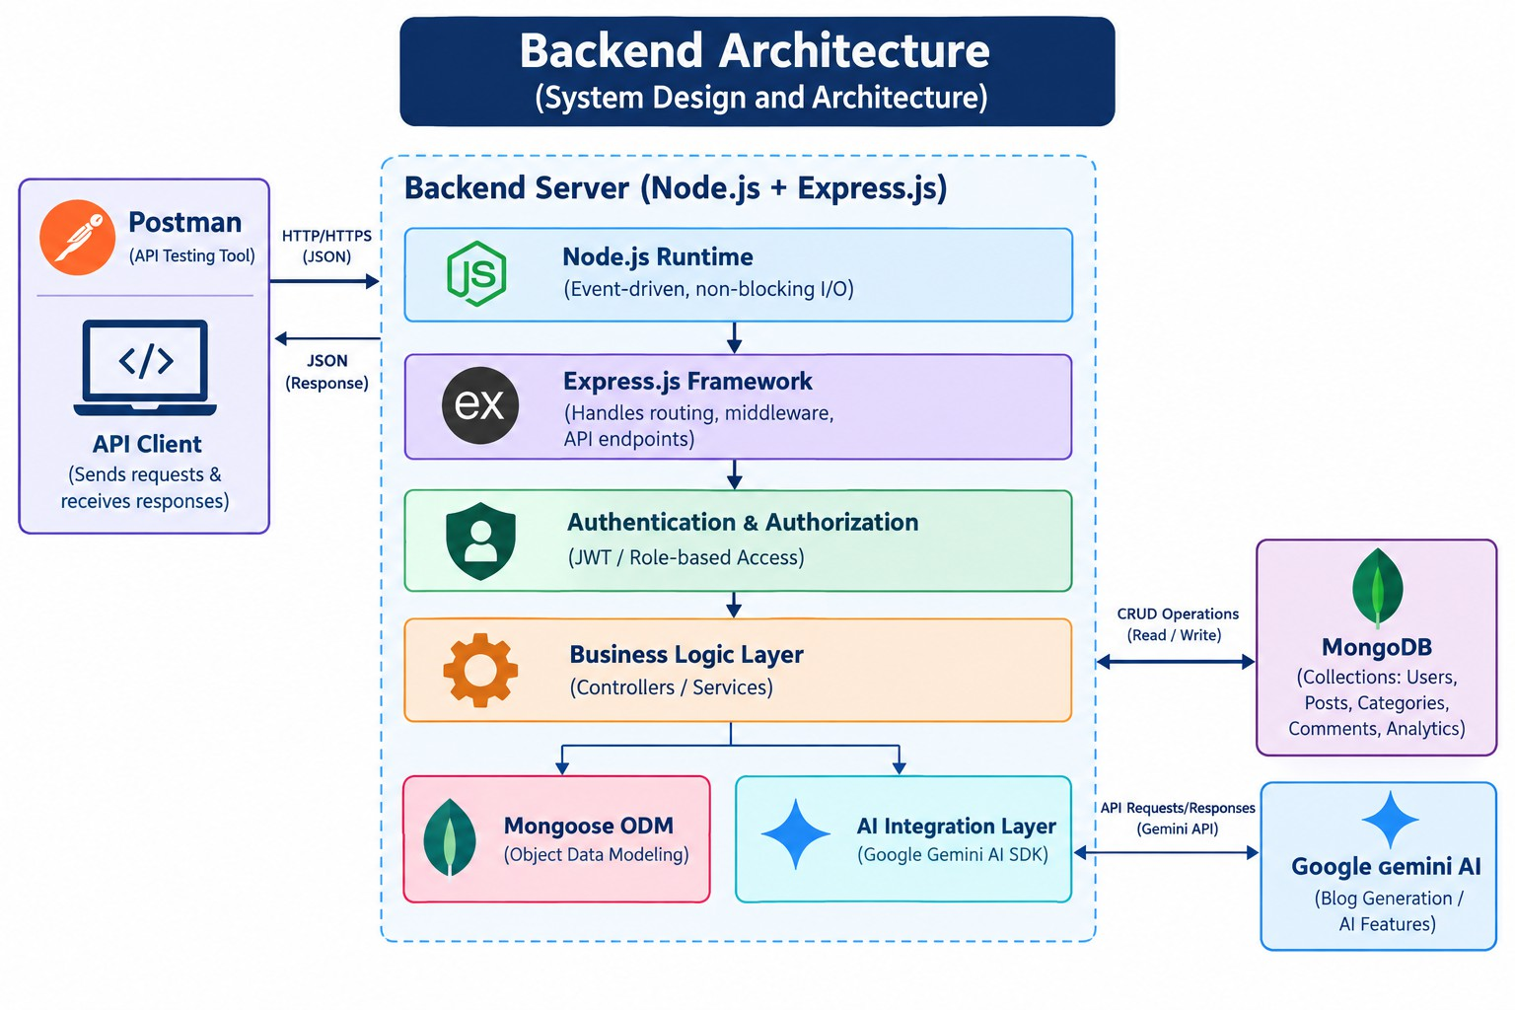
Backend Architecture Explanation:
  - The API request is sent through Postman/API Client to the Node.js and Express.js backend.
  - Authentication, authorization, and business logic process the request and manage the
required operations.
  - Mongoose connects with MongoDB for data storage, while the Google Gemini AI layer handles AI-based blog generation and features.
Components Definition
- Postman / API Client
Used to send API requests and test different backend endpoints. It helps verify whether the API is working correctly and returns the expected responses.
- Node.js Runtime
Provides the execution environment for running the backend application. It handles server-

side JavaScript execution and supports efficient request processing.
- Express.js Framework
Provides the framework for creating REST API endpoints. It manages routing, HTTP requests, responses, and middleware used by the application.
- Authentication & Authorization
Provides secure access to the application using JWT authentication. Role-based authorization ensures that users can perform operations according to their assigned roles.
- Business Logic Layer
Contains the main application logic through controllers and services. It processes user requests, performs required operations, and communicates with other components.
- Mongoose ODM
Acts as a connection layer between the application and MongoDB. It defines data schemas, validates data, and performs database operations.
- MongoDB
Acts as the main database for storing application information. It stores data related to users, blog posts, categories, comments, and other required records.
- Google Gemini AI
Provides Artificial Intelligence capabilities for the application. It supports AI-assisted blog content generation and other intelligent content-related features.

DATABASE ENTITY MAPPING
The database entity mapping of AI BlogNest illustrates the connection between the main entities involved in blog management. The User entity maintains user details and roles, while the Post entity stores the blog information created by users.
The Comment entity connects users with blog posts by storing comments made on specific posts. These entity relationships provide a structured way to store, retrieve, and manage blog-related information in the database.

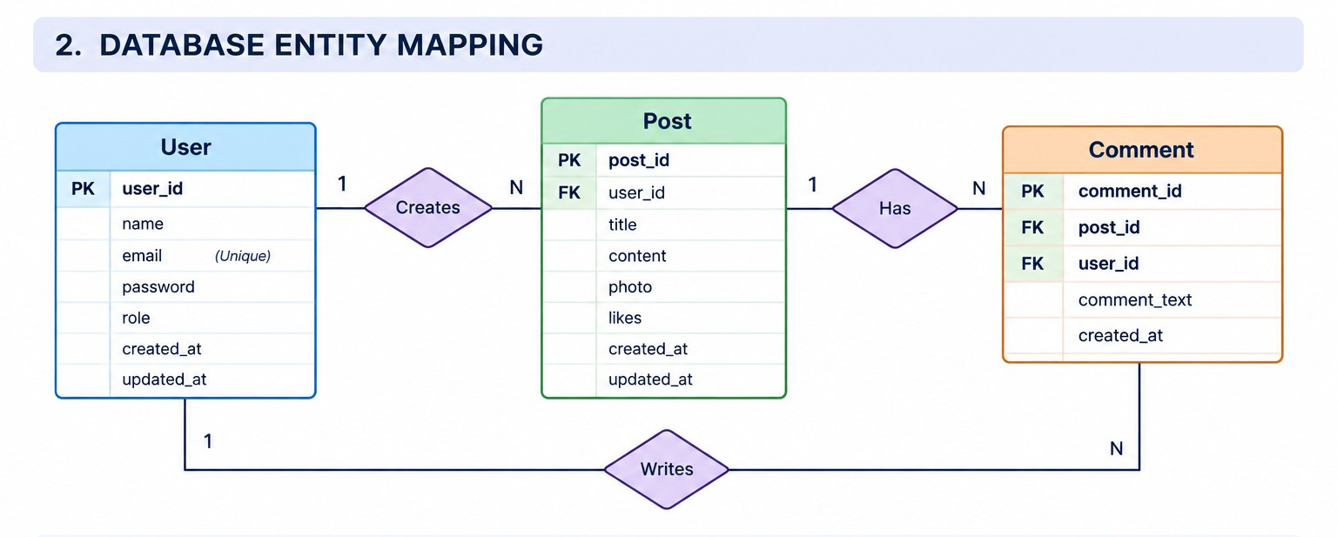
DATABASE ENTITY MAPPING
Diagram Description
The database entity mapping of AI BlogNest shows the relationship between the main entities used in the blogging system. The User entity stores user details and roles, while the Post entity stores blog information created by users.
The Comment entity stores comments related to users and blog posts. These relationships help the system organize and manage blog data in a structured manner.

Key Entities
- User – Stores user details and role information.
- Post – Stores blog post details and creator information.
- Comment – Stores comments related to users and blog posts.

Relationships
- One User can create multiple Posts.
- One User can create multiple Comments.
- One Post can have multiple Comments.

KEY STRUCTURE
The main database structure of AI BlogNest consists of three important entities: User, Post, and Comment.
- User – Stores user information such as ID, name, email, password, and role.
- Post – Stores blog information such as post ID, user ID, title, content, photo, likes, and timestamps.

- Comment – Stores comments related to users and blog posts.
- User–Post Relationship – One user can create multiple posts.
- User–Comment Relationship – One user can create multiple comments.
- Post–Comment Relationship – One post can have multiple comments.
This structure maintains the connection between users, blog posts, and comments in the database.

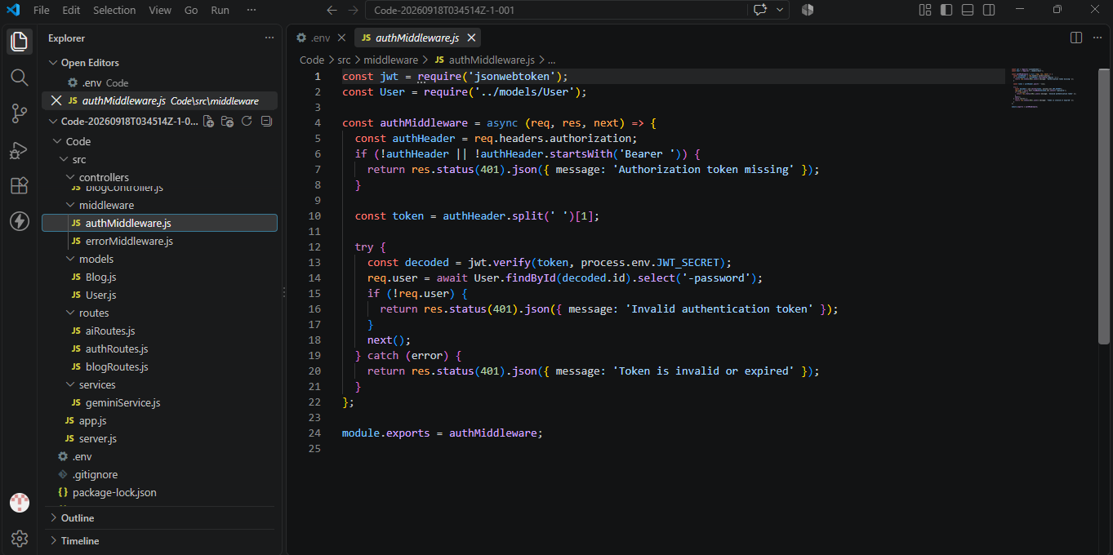

KEY FEATURES
- AI-Assisted Content Creation – Helps users generate blog content using Google Gemini AI.
- AI Content Summarization – Creates concise summaries from existing blog content.
- CRUD Operations – Supports creating, viewing, updating, and deleting blog posts.
- Blog Content Management – Helps users organize and manage their blog posts efficiently.
- User Authentication – Provides secure user authentication using JWT.
- Role-Based Access Control – Provides different permissions for Admin, Editor, Author, and Reader.
- Category and Tag Management – Helps organize blog posts based on categories and tags.
- Comment Management – Supports adding and managing comments related to blog posts.
- Database Integration – Uses MongoDB with Mongoose for storing and managing application data.
- Security and Validation – Includes password hashing, request validation, input sanitization, rate limiting, and centralized error handling.

ROLES AND RESPONSIBILITIES
AI BlogNest supports different user roles, where each role is assigned specific responsibilities and access permissions.
- Admin – Responsible for overall system administration, user management, role management, and controlling application activities.
- Editor – Responsible for reviewing blog content, managing posts, and supporting the content publishing process.
- Author – Responsible for creating and managing blog posts and using AI features to assist in content creation.
- Reader – Responsible for accessing published blog posts and interacting with the content through comments.
Role-based access helps maintain proper control over system operations and ensures that users can access features according to their assigned responsibilities.

ROLE-BASED ACCESS FLOW
User Login → JWT Authentication → Role Veriflcation → Permission Check → Role-Speciflc Access → System Operation → Response
- User Login – User provides login credentials.
- JWT Authentication – System verifies the user credentials and validates the JWT token.
- Role Veriflcation – System identifies the user's assigned role.
- Permission Check – System checks whether the role has permission for the requested operation.
- Role-Speciflc Access – Admin, Editor, Author, or Reader gets access according to their permissions.
- System Operation – The permitted action is performed.
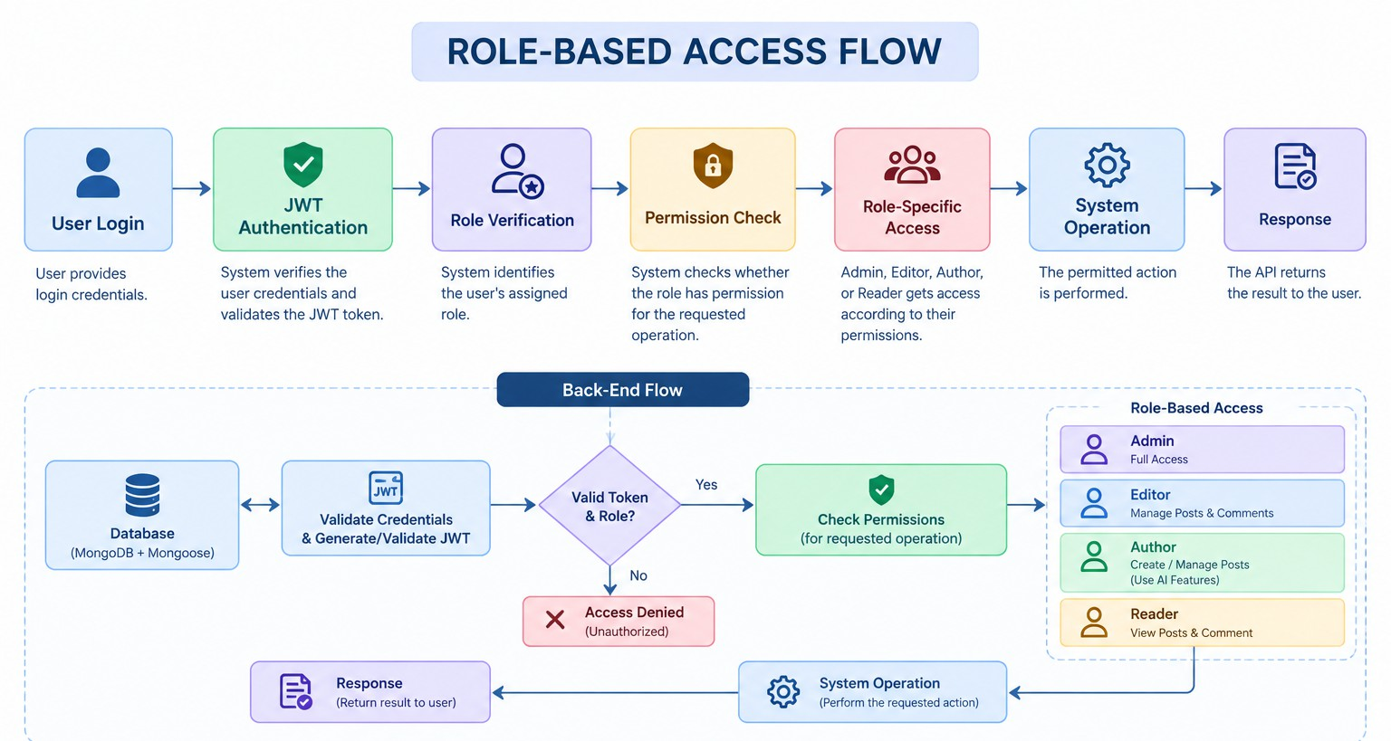
- Response – The API returns the result to the user.

BACKEND ARCHITECTURE MODEL
AI BlogNest follows a structured backend architecture that separates database management, application processing, and API request handling.

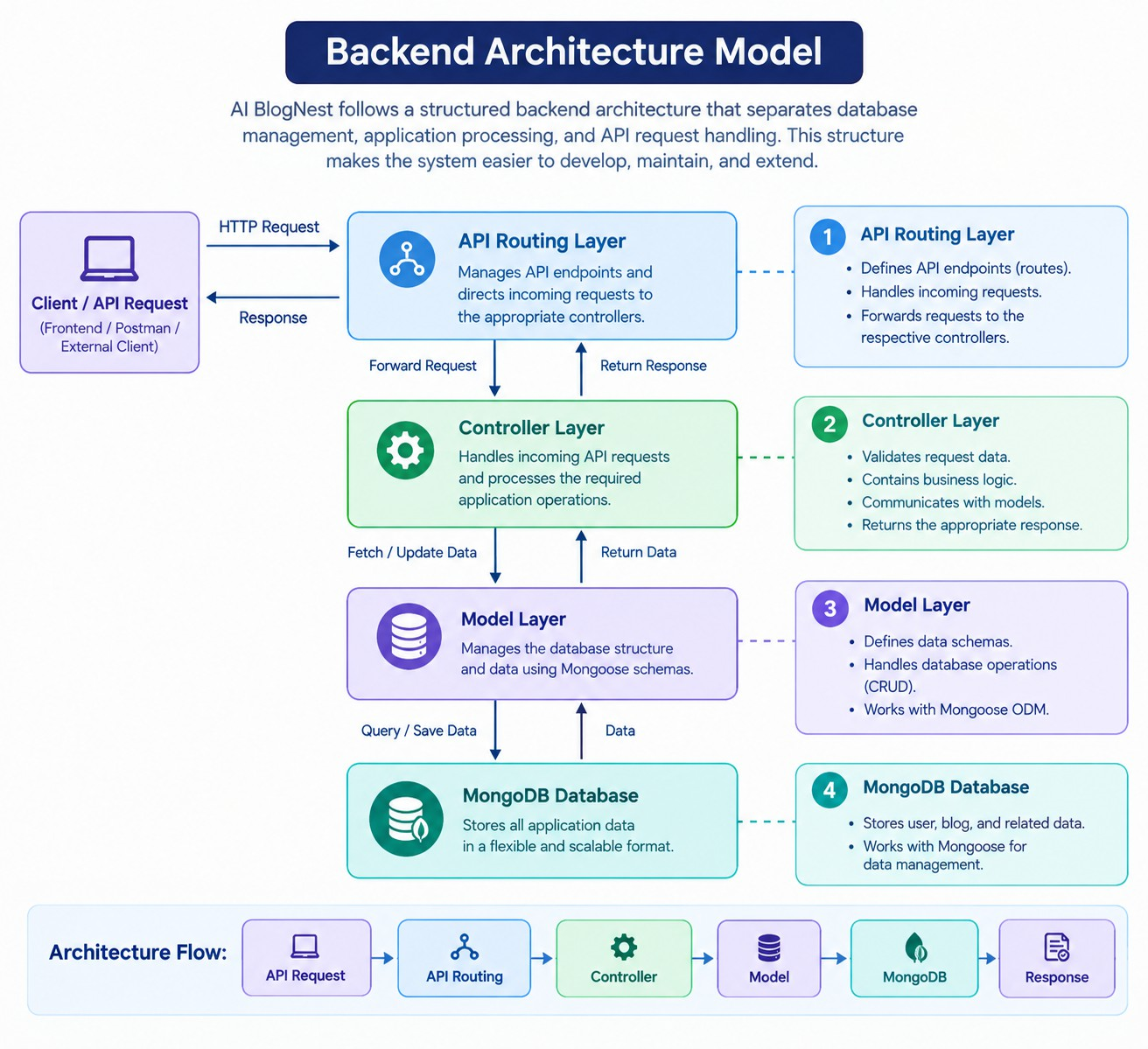
This structure makes the system easier to develop, maintain, and extend.

BACKEND ARCHITECTURE MODEL
- API Routing Layer – Manages API endpoints and directs incoming requests to the corresponding controllers. It provides the

communication path between the client/API tool and the backend operations.
- Controller Layer – Handles incoming API requests and processes
the required application operations. It performs request validation, communicates with the models, and returns the appropriate response.
- Model Layer – Manages the database structure and data using
Mongoose schemas. It defines how user, blog, and related information is stored in MongoDB.
- MongoDB Database – Stores the application's user, blog, and
related data. It works with Mongoose for database operations and data management.
Architecture Flow:
API Request → API Routing → Controller → Model → MongoDB → Response

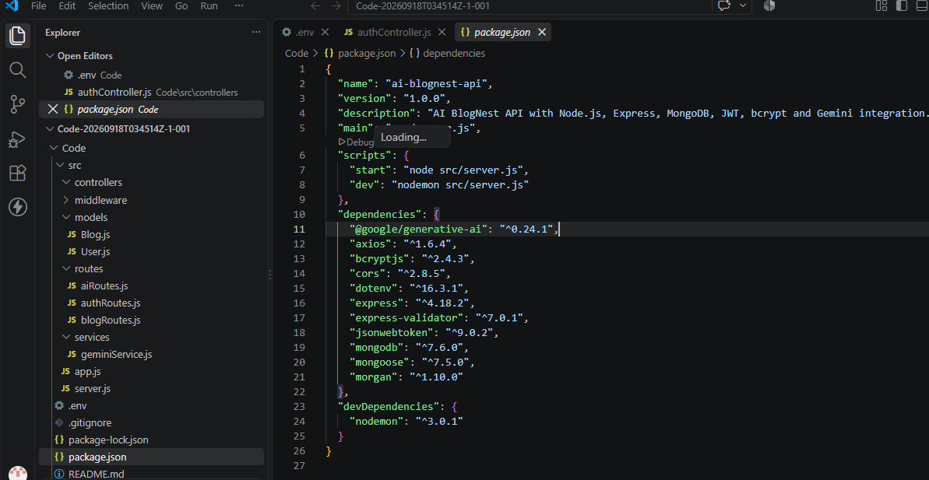

PROJECT INITIALIZATION AND SETUP

PROJECT INITIALIZATION AND SETUP
- Project Workspace Creation
  - Create a new folder for the AI BlogNest project.
  - Create a separate Server folder inside the project workspace.
  - Open the project folder in Visual Studio Code.
- Backend Package Initialization
  - Open the Server folder in the VS Code terminal.
  - Initialize the Node.js project using: npm init -y
- Backend File Organization
Create the main server file:

  - server.js
Create the following folders:
  - models – Database models and schemas
  - controllers – Application request processing
  - routes – API endpoint definitions
Setup Flow
Project Folder → Server Folder → VS Code → npm Initialization → Server File
→ Models / Controllers / Routes

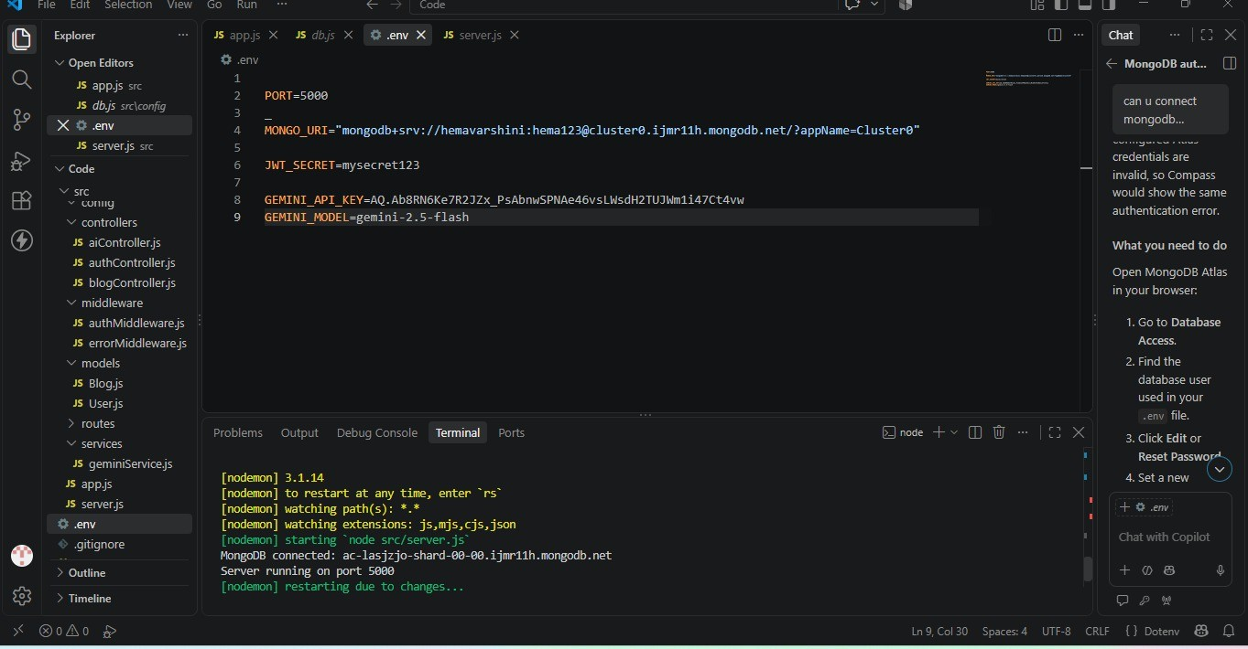
1. Server Environment Setup
The backend server is configured using Node.js and Express.js. The required environment variables are maintained in a .env file for server and application configuration.
- Server Configuration

The server configuration includes:
- PORT – Defines the port on which the backend server runs.
- MONGO_URI – Stores the MongoDB connection configuration.
- JWT_SECRET – Used for JWT-based authentication.
- GEMINI_API_KEY – Used for Google Gemini AI integration.
- GEMINI_MODEL – Specifies the Gemini AI model used by the application.
- Backend Server Execution
The backend server is started through the Node.js environment. In the screenshot, the server is running on port 5000, and the terminal shows a successful MongoDB connection.

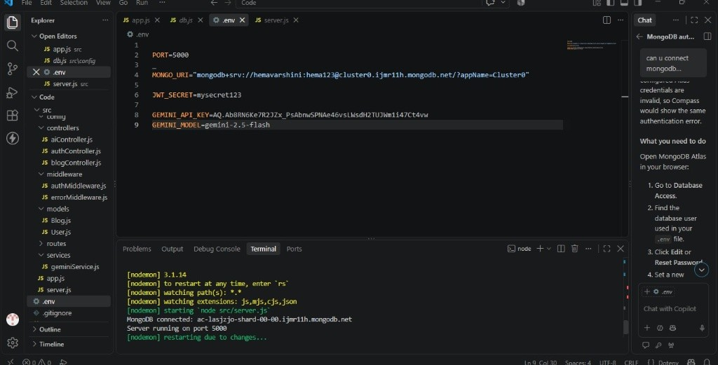
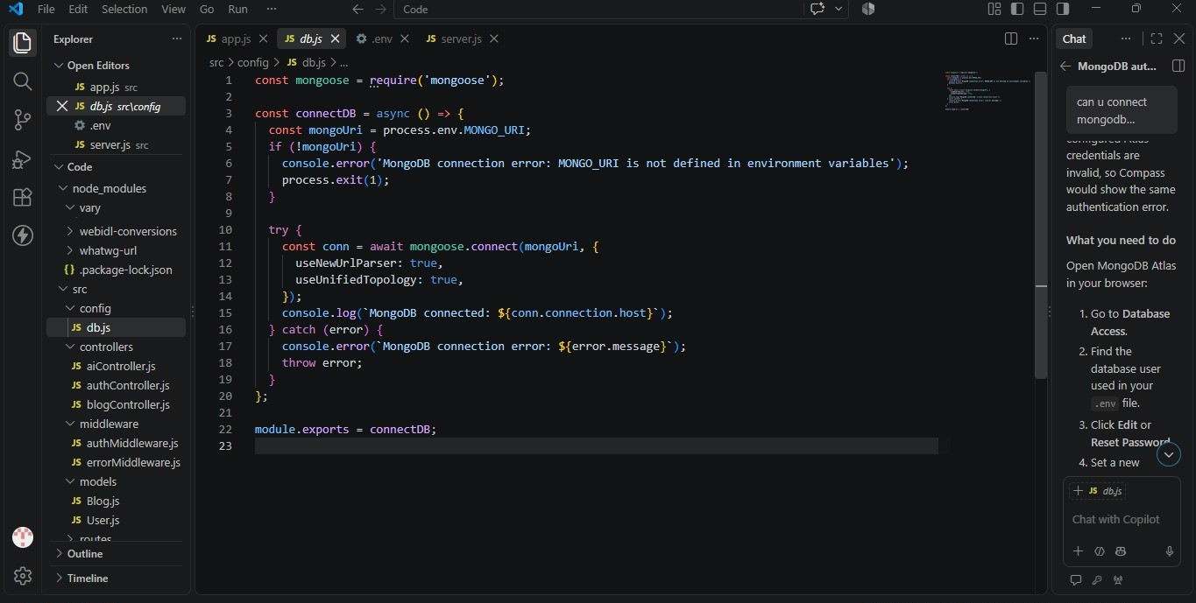
BACKEND APPLICATION DEVELOPMENT

MONGOOSE DATABASE CONNECTIVITY
Mongoose is used in AI BlogNest to establish communication between the Node.js backend and MongoDB database. It provides an organized way to define data structures and perform database operations from the application.

DATABASE CONNECTION SETUP
The application connects to MongoDB through a configured database connection. The connection is established before performing backend operations, ensuring that application data can be stored and retrieved from the database.

SCHEMA DEFINITION
Mongoose schemas are used to define the structure and validation rules of the data stored in MongoDB. The schemas specify the required fields and their corresponding data types for application entities.

DATA MODEL CREATION
Models are created from the defined Mongoose schemas to interact with MongoDB collections. AI BlogNest uses data models for managing information related to users and blog posts.

DATABASE OPERATION FLOW
The backend sends data operations through Mongoose, which communicates with the MongoDB database. This allows the application to perform required data storage and retrieval operations in a structured manner.

DATABASE CONNECTION

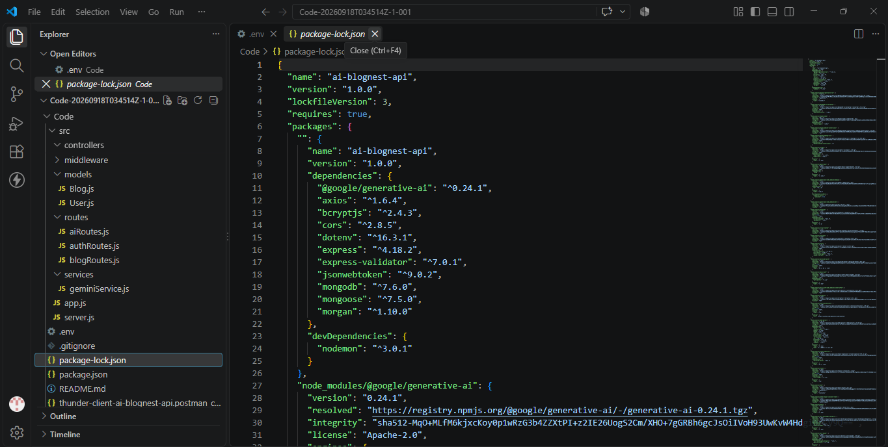

SYSTEM EXECUTION AND API VALIDATION
The AI BlogNest backend is executed through the Node.js environment and tested using an API testing tool such as Postman or ThunderClient. The backend server is started using the configured start command, allowing the available API endpoints to be tested.

- Backend Server Execution
The backend server is started using the project configuration. Once the server is running and the database connection is established, the API endpoints are ready for testing.

API Testing
Postman or ThunderClient is used to send requests to the backend API and verify the responses returned by the system.

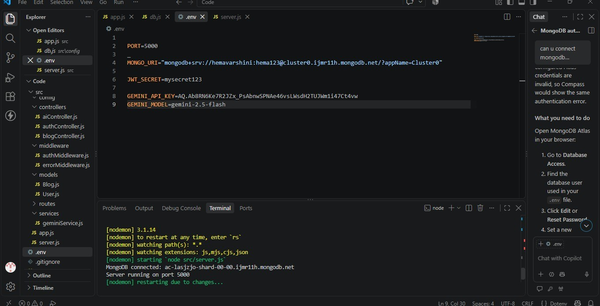
- User Registration
The user registration API is tested by providing the required user details and checking whether the registration request is processed successfully.

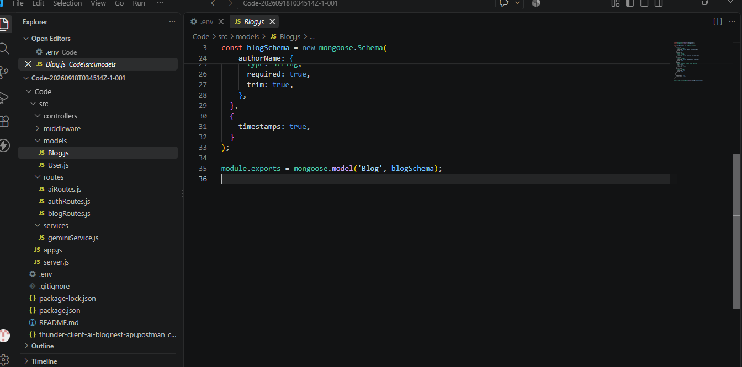

4.User Login
The login API is tested using valid user credentials. The response is checked to verify successful authentication.

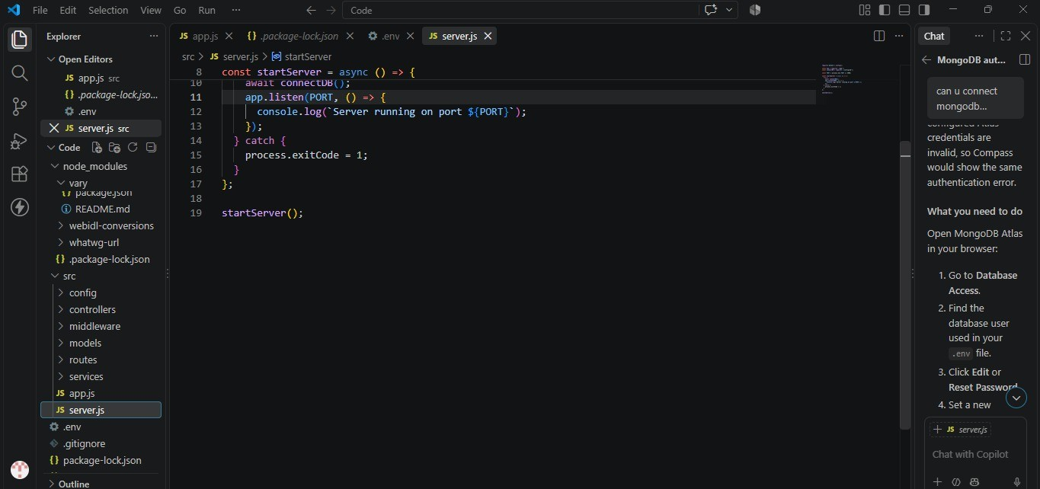
- Blog Operations

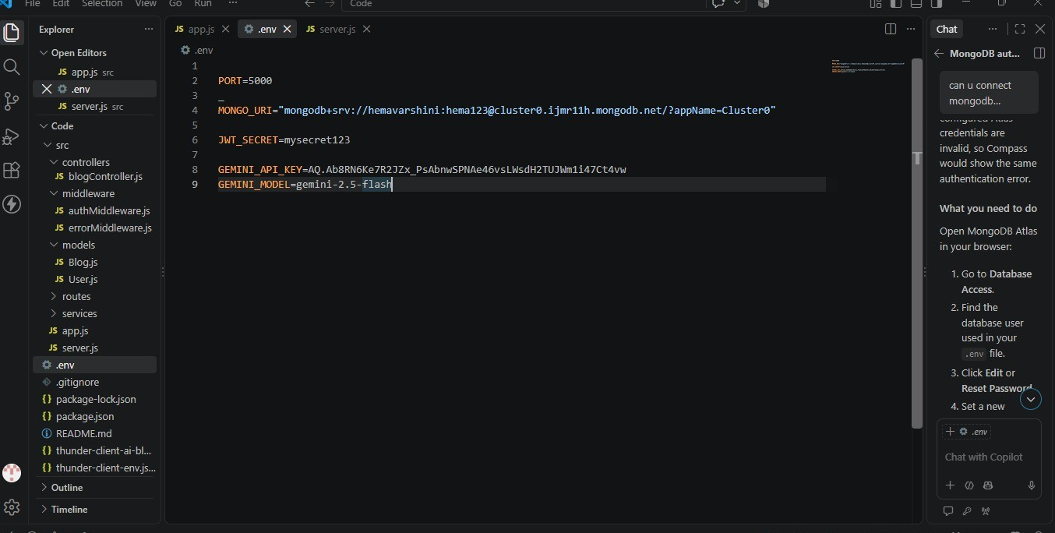
The blog APIs are tested for creating and retrieving blog posts. These tests help verify that blog-related operations are working correctly.

- AI Features
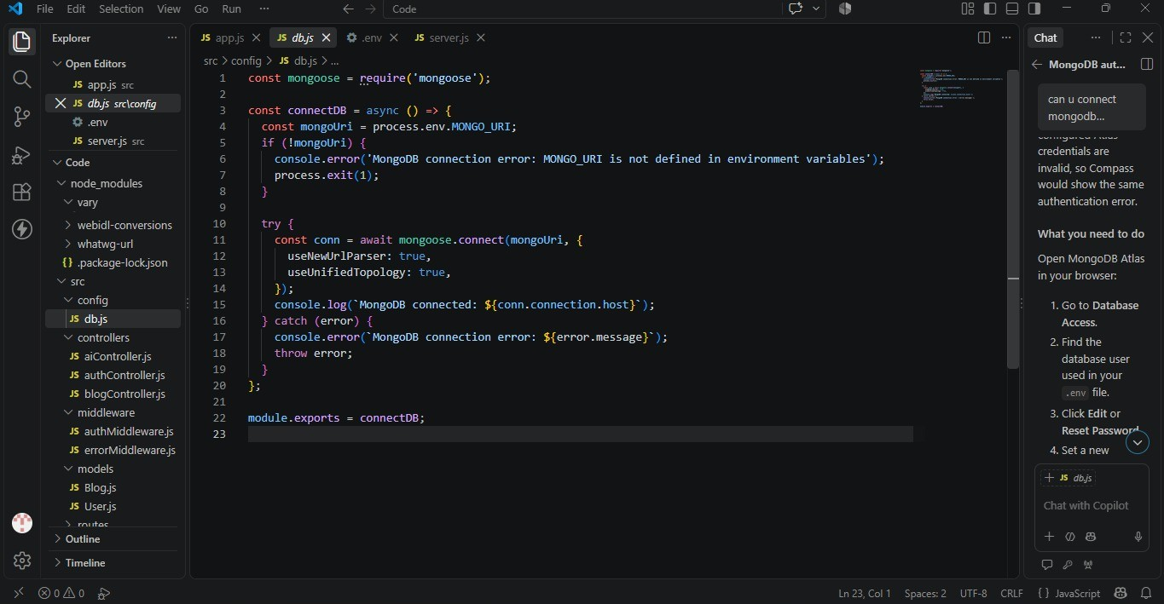
The AI-related APIs are tested for blog generation and blog summarization. The generated response is checked to ensure that the AI functionality is properly connected to the backend.

API Testing Flow
Start Server → Connect Database → Send API Request → Process Request → Execute Operation → Return API Response
→ Validate Result
These testing activities are aligned with the source documentation's listed execution and API tests: user registration, user login, create blogs, fetch blogs, generate AI blogs, and summarize blogs.

CONCLUSION
AI BlogNest is an AI-powered blogging and content management system developed to simplify the process of creating, managing, and organizing blog content. The system combines Node.js, Express.js, MongoDB, Mongoose, and Google Gemini AI to provide efficient backend services.
The application supports important features such as user authentication, role-based access, blog CRUD operations, comments, AI-based blog generation, and content summarization. API testing through Postman or ThunderClient helps verify the major system operations and ensure that the backend services function as expected.
Overall, AI BlogNest provides a secure, structured, and AI-assisted platform that reduces the effort involved in blog creation and management while maintaining organized data and controlled user access.

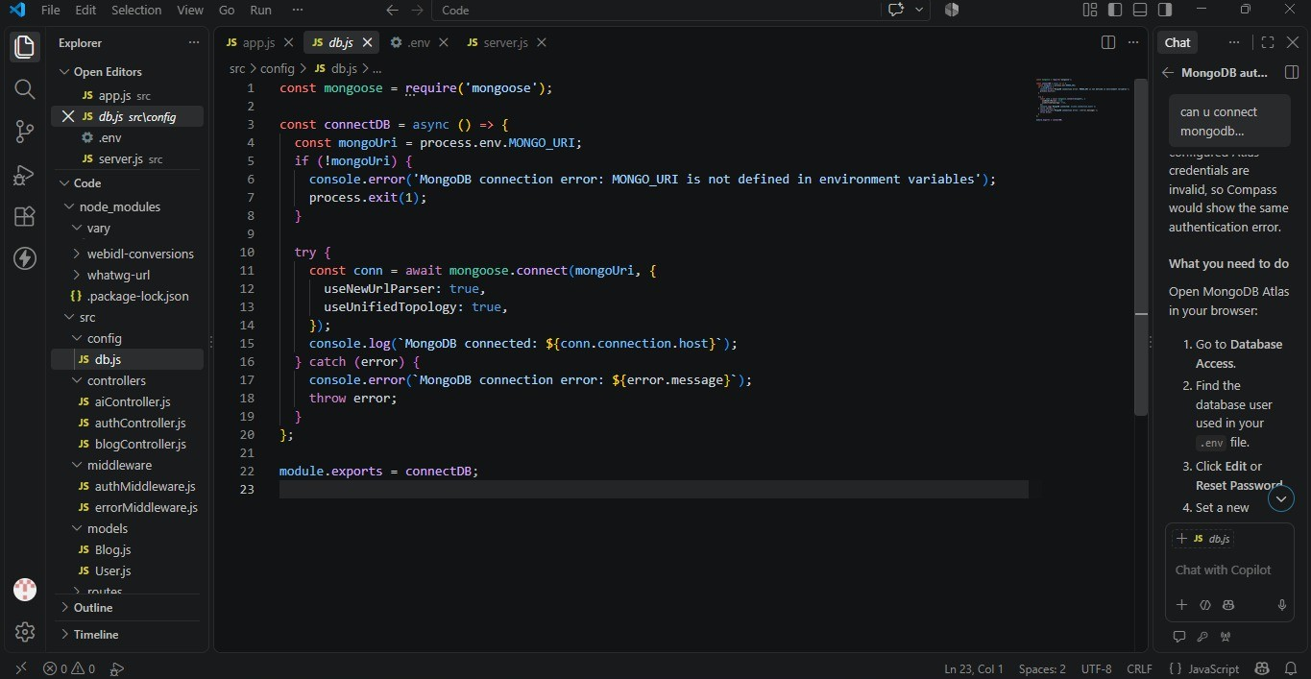
DEMO VIDEO : https://drive.google.com/file/d/1PqvI8b4NL-HjSAV8XoRuVqzRrTr0k5KX/view?usp=drivesdk

